Configure SSH Access to a Docker Container for Developers
Dockerfile:
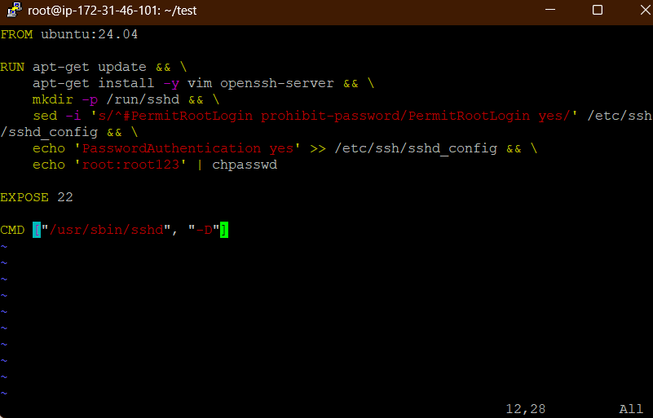
Sshd image built:
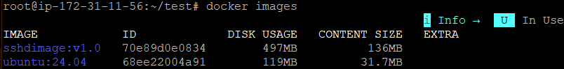
Container:
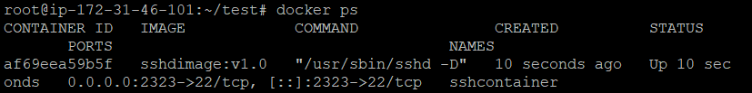

Container running and testing:
